**Q1 Create database**

1. COLLEGE DATABASE:

STUDENT (USN, SName, Address, Phone, Gender)

SEMSEC (SSID, Sem, Sec)

CLASS (USN, SSID) SUBJECT (Subcode, Title, Sem, Credits)

IAMARKS (USN, Subcode, SSID, Test1, Test2, Test3, FinalIA)



**Use Database**

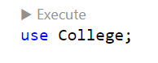

**Create table -1 Student**

create table student(

    SSN int not null primary key,

    SNAME varchar(50),

    ADDRESS VARCHAR(100),

    PHONE bigint,

    GENDER CHAR(10)

);

**Insert values**

INSERT into student values(1,"AMAN",'Keshav Puram',5768480458,"M");

INSERT into student values(2,"Lakshay",'Keshav Puram',578480458,"M");

INSERT into student values(3,"Dev",'kalkaji',508480458,"M");

INSERT into student values(4,"Anvi",'Tri Nagar',57684804,"F");

INSERT into student values(5,"Harsh",'Gurugram',999880458,"M");

INSERT into student values(6,"Sunita",'Lawrence Road',566480458,"F");

SELECT * FROM student;

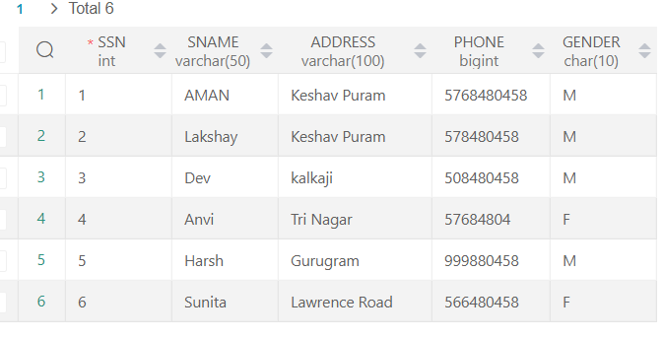

**Create table-2 SEMSEC**

create table semsec(SSID int,Sem VARCHAR(10),Sec CHAR(5));

INSERT into semsec VALUES(101,"2nd","A");

INSERT into semsec VALUES(102,"4th","B");

INSERT into semsec VALUES(103,"1nd","A");

INSERT into semsec VALUES(104,"3rd","C");

INSERT into semsec VALUES(105,"1nd","D");

SELECT *FROM semsec;

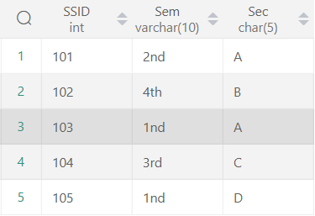

**Create table - 3 CLASS**

CREATE Table CLASS(USN int,SSID int);

INSERT INTO CLASS VALUES(1,101);

INSERT INTO CLASS VALUES(2,102);

INSERT INTO CLASS VALUES(3,103);

INSERT INTO CLASS VALUES(4,104);

INSERT INTO CLASS VALUES(5,105);

SELECT * FROM CLASS;

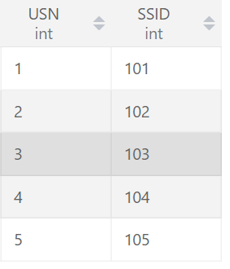

**Create table – 4 Subject**

CREATE TABLE subject(Subcode BIGINT,Title VARCHAR(80),Sem VARCHAR(10),Credits int);

INSERT INTO subject VALUES(201,"Accounts","2nd",2);

INSERT INTO subject VALUES(202,"I.P","2nd",2);

INSERT INTO subject VALUES(203,"Economics","2nd",4);

INSERT INTO subject VALUES(204,"Science","2nd",4);

INSERT INTO subject VALUES(205,"Bst","2nd",4);

INSERT INTO subject VALUES(206,"Accounting","2nd",4);

SELECT *from subject;

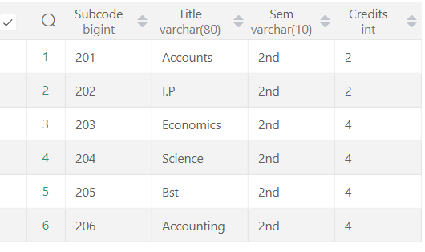

**Create table - 5 IAMARKS**

CREATE TABLE IAMARKS(USN int,Subcode BIGINT,SSID int,Test1 int,test2 int,Test3 int, FinallA BIGINT);

INSERT into iamarks VALUES(1,201,101,99,99,99,297);

INSERT into iamarks VALUES(2,202,102,98,99,99,296);

INSERT into iamarks VALUES(3,203,103,92,90,99,281);

INSERT into iamarks VALUES(4,204,104,98,96,95,289);

INSERT into iamarks VALUES(5,205,105,94,93,98,285);

SELECT * from IAMARKS;

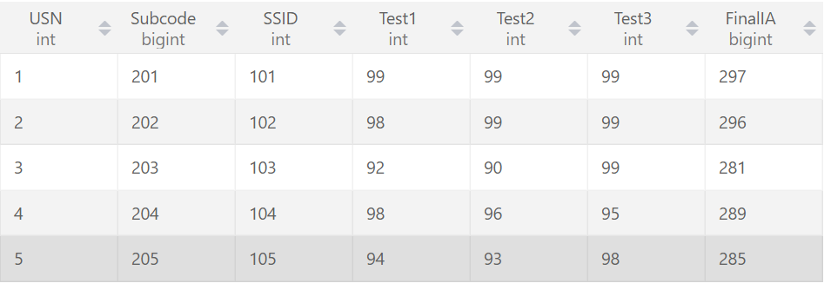

**2.COMPANY DATABASE:**

EMPLOYEE (SSN, Name, Address, Sex, Salary, SuperSSN, DNo)

DEPARTMENT (DNo, DName, MgrSSN, MgrStartDate)

DLOCATION (DNo,DLoc)

PROJECT (PNo, PName, PLocation, DNo)

WORKS_ON (SSN, PNo, Hours)

Create database Company ;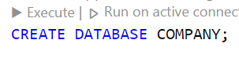

**Use Database**

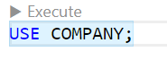

**Create table - 1 Employee**

CREATE TABLE EMPLOYEE(

    SSN int NOT NULL PRIMARY KEY ,

    Name VARCHAR(50),

    Address VARCHAR(150),

    Sex CHAR(10),

    Salary BIGINT,

    SuperSSN INT,

    DNO INT

);

**Insert values in Employee table**

INSERT into employee VALUES(1,"Lakshay","Keshav Puram Delhi-110035","M",150000,101,201);

INSERT into employee VALUES(2,"Puneet","lok Puri Delhi pin -110091","M",140000,102,202);

INSERT into employee VALUES(3,"Aman Sharma","Trilok court Delhi pin -110091","M",140000,103,203);

INSERT into employee VALUES(4,"Kavya","Trilok Pune Delhi pin -110091","F",154000,104,204);

INSERT into employee VALUES(5,"Yamini"," Camp, Khadki, and Dehu Road, Pune","M",155000,105,205);

INSERT into employee VALUES(6,"Komal","Khadki, and Dehu Road, Pune","F",150600,106,206);

SELECT * FROM employee;

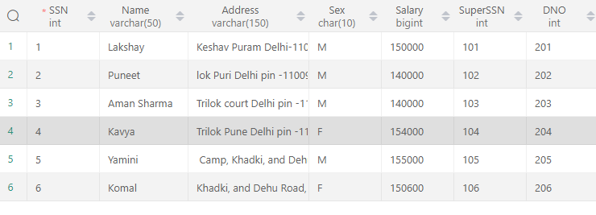

**Create table – 2 Department and Insert values**

CREATE Table DEPARTMENT(DNO INT,DName VARCHAR(60),MgrSSN BIGINT,MgrStartDate DATE);

INSERT into department VALUES(201,"Lakshay",101,"2016-02-28");

INSERT into department VALUES(202,"Dev",102,"2022-05-17");

INSERT into department VALUES(203,"Aman Sharma",103,"2016-06-16");

INSERT into department VALUES(204,"Puneet",104,"2015-09-19");

INSERT into department VALUES(205,"Kavya",105,"2021-02-22");

SELECT *from department;

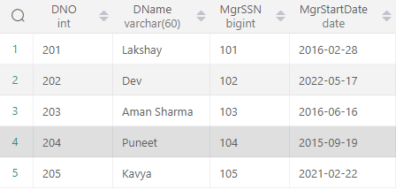

**Create table - 3 DLOCATION and Insert values**

CREATE TABLE DLOCATION(DNO int,DLoc int);

INSERT into DLOCATION VALUES(201,501);

INSERT into DLOCATION VALUES(202,502);

INSERT into DLOCATION VALUES(203,503);

INSERT into DLOCATION VALUES(204,504);

INSERT into DLOCATION VALUES(205,505);

SELECT *FROM dlocation;

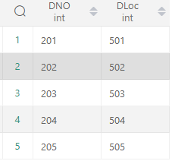

**Create table - 4 PROJECT and Insert values**

CREATE Table PROJECT(PNo int, PName VARCHAR(50), PLocation VARCHAR(60),DNO int);

INSERT into project values (1,"Ai Power", "Model Town",201);

INSERT into project values (2,"ML Power", "Kanhiya Nagar",202);

INSERT into project values (3,"Ai human", "Kirti Nagar",203);

INSERT into project values (4,"Ai make New World", "Model Town",204);

INSERT into project values(5,"ML gives us new Power", "Gurgaon ",205);

select *from PROJECT;

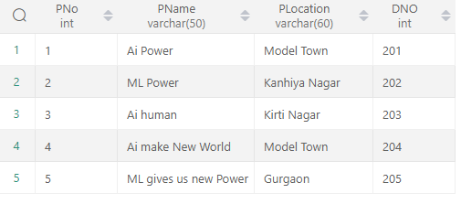

**Create table – 5 WORKS_ON and Insert values**

CREATE Table WORKS_ON(SSN INT,PNO int,Hours time);

INSERT into WORKS_ON VALUES(1,11,'10:30:10');

INSERT into WORKS_ON VALUES(2,22,'12:30:10');

INSERT into WORKS_ON VALUES(3,33,'01:30:10');

INSERT into WORKS_ON VALUES(4,44,'09:30:10');

INSERT into WORKS_ON VALUES(5,55,'08:30:10');

SELECT * FROM WORKS_ON;

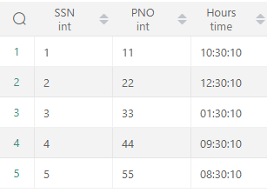

**Q1)Draw an E-R diagram from given entities and their attributes**

CLASS

SEMSEC

STUDENT

1 1

1

GOT

CLASSTEST

n

n

SUBJECT

IAMARKS

SUBJECT

SCORE

n n

**Program 3:-**Write queries to execute following DDL commands :

1. CREATE :
2. ALTER:
3. DROP:

Create command query

CREATE table studnt(

id int,

Name VARCHAR(40),

Program VARCHAR(30),

Enrolment_no BIGINT,

Credit int

);

desc studnt;

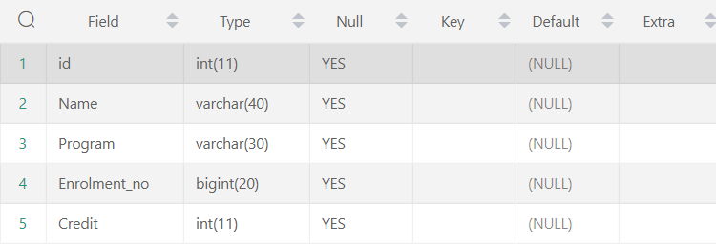

INSERT into studnt VALUES(1,'Aman','MCA',018287188,4);

INSERT into studnt VALUES(2,'Ujjwal','BCA',764276327,3);

INSERT into studnt VALUES(3,'Aditya','BCA',290982438328,2);

INSERT into studnt VALUES(4,'Sarthak','MCA',324654367,4);

INSERT into studnt VALUES(5,'Karan','BCA',5477676565,3);

SELECT * FROM studnt;

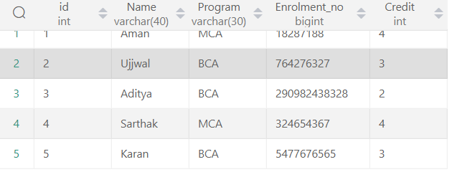

Q4 Alter command query

Change the size of a particular column.

alter TABLE studnt

MODIFY COLUMN Program char(50);



Add a new column to the existing table.

ALTER TABLE studnt

add COLUMN hello int;



Remove a column from the table.

Alter TABLE student

drop COLUMN hello;

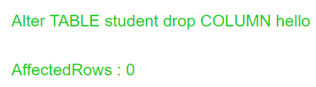

DROP: Destroy the table along with its data.

drop TABLE student;

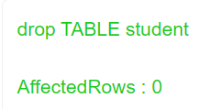

**Program 4:-**Write queries to execute following DML commands :

INSERT: Insert five records in each table.

UPDATE: Modify data in single and multiple columns in a table

DELETE: Delete selective and all records from a table.

Insert five records in table.

INSERT into studnt VALUES(1,'Aman','MCA',018287188,4);

INSERT into studnt VALUES(2,'Ujjwal','BCA',764276327,3);

INSERT into studnt VALUES(3,'Aditya','BCA',290982438328,2);

INSERT into studnt VALUES(4,'Sarthak','MCA',324654367,4);

INSERT into studnt VALUES(5,'Karan','BCA',5477676565,3);

Modify data in single and multiple columns in a table

UPDATE studnt set Program ="Btech" WHERE id = 1;



DELETE: Delete selective and all records from a table.

DELETE FROM studnt where id =3;

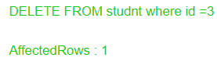

DELETE FROM student;

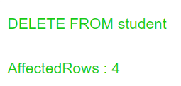

**Program 5:-** Write queries to execute following DML command :

SELECT: Retrieve the entire contents of the table.

Retrieve the selective contents (based on provided conditions) from a table.

Retrieve contents from a table based on various operators

i.e. string operators, logical operators and conditional operators, Boolean operators.

Sort the data in ascending and descending order in a table on the basis of one column or more than one column.

SELECT * FROM pin;

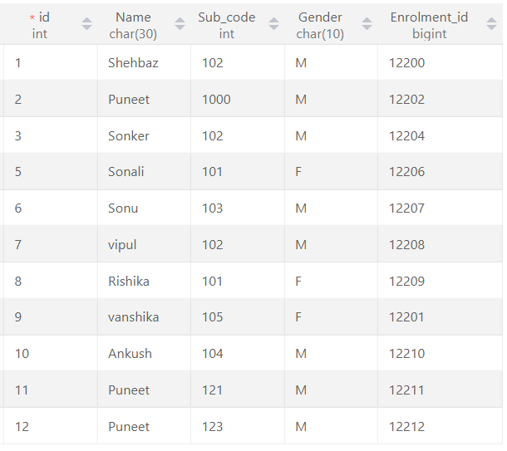

use hello;

SELECT *from best1;

-- String Operations

-- There are the two string operators:

--          Percent (%)  :  This Operator (%) matches any substring.

--          Underscore ( _ ) : This Operator ( _ ) matches any character.

-- String Operator

SELECT id, FName, Program FROM best1 WHERE FName LIKE 'Sh%';

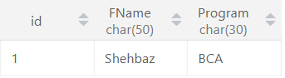

SELECT id, FName, Program, Department FROM best1 WHERE FName LIKE '_ha%';

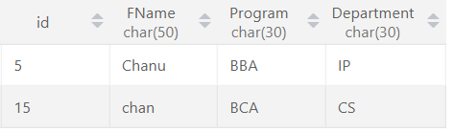

SELECT id, FName, Enrol_no FROM best1 WHERE FName LIKE 'Sal_%';

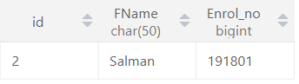

SELECT id, FName, Program, Dep_ID FROM best1 WHERE FName LIKE 'S__';

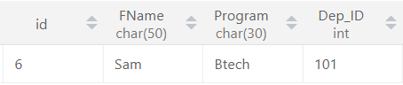

-- ......Logical Opreators........

-- .....also We can use And(&&),OR(||) NOT(!).....

SELECT * from pin;

SELECT * FROM pin WHERE id <= 3 AND Gender = "M";

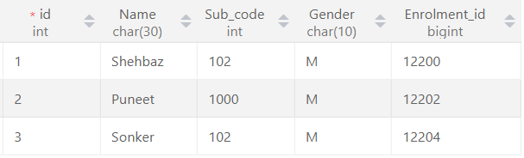

SELECT id, Name FROM pin WHERE id = 6 || id = 1;

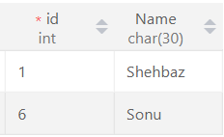

SELECT id, Name FROM pin WHERE  not(id = 6 OR id = 1);

SELECT id, Name FROM pin WHERE id  BETWEEN 5 AND 9;

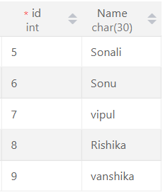

SELECT id, FName, Program FROM best1 WHERE Program IN('BCA' ,'BBA');

SELECT id, FName, Program FROM best1 WHERE FName LIKE 'S%';

SELECT id, FName, Program FROM best1 WHERE FName LIKE '_aa%';

SELECT * FROM best1 WHERE Program = ALL (SELECT Program FROM best1 WHERE Program = 'BCA');

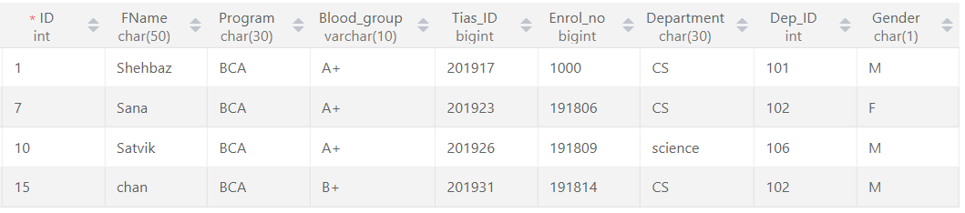

🡪 Arithmetic Operators ( + - * / % )

SELECT 40 + 20;

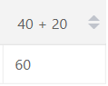

SELECT 40 - 20;

SELECT 40 * 20;

SELECT 40 / 20;

SELECT 40 % 21;

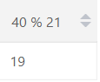

-- Comparision Operator < > >= <= !> <! == != ,.....,

SELECT * FROM pin ;

SELECT *FROM Pin where id >5;

SELECT *FROM Pin where id <5;

SELECT *FROM Pin where id >=5;

SELECT *FROM Pin where id <= 5;

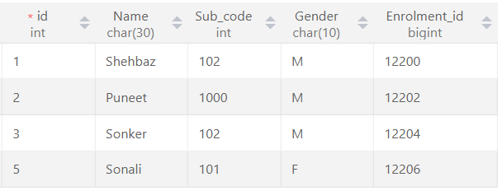

SELECT *FROM Pin where id != 5;

***Sort Table In Ascending Order by name basis of one column or more than one column.

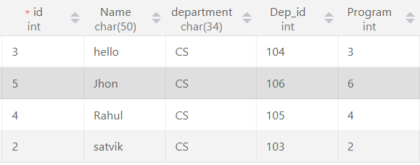SELECT *from best ORDER BY Name; SELECT *from best ORDER BY Name ,Program;   
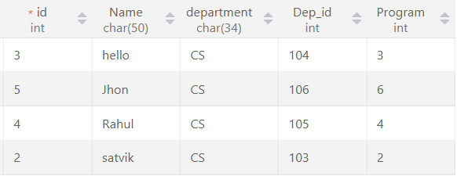

Sort Table In descending Order by name basis of one column or more than one column.

SELECT *from best ORDER BY Name DESC; SELECT *from best ORDER BY Name ,Program DESC;

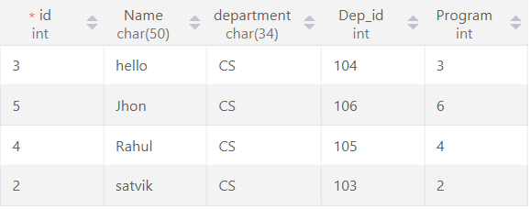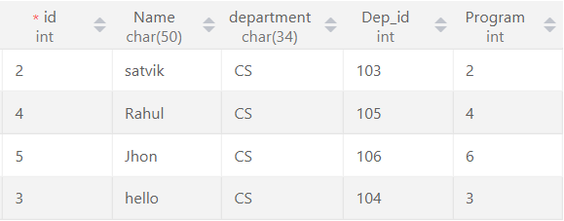

**Practical:-6** Create table using following integrity constraints:

1. Primary Key
2. Unique Key
3. Not Null
4. Check Default
5. Foreign Key

-- Child table for REFERENCES FOREIGN KEY;

CREATE TABLE City(

    ID INT ,

    City VARCHAR(160),

    PRIMARY KEY(ID)

    );

insert INTO city VALUES(1,"Delhi");

insert INTO city VALUES(2,"Mumbai");

insert INTO city VALUES(3,"Kerala");

insert INTO city VALUES(4,"Goa");

insert INTO city VALUES(5,"Karnatka");

SELECT *from city;

ALTER TABLE city  RENAME  COLUMN  ID to C_ID;

CREATE Table Personal(

    ID INT NOT NULL UNIQUE,

    Code_NO INT UNIQUE,

    FNAME VARCHAR(60) NOT NULL,

    Age INT NOT NULL check (Age >=18),

    Phone_no VARCHAR(10) UNIQUE,

    MyArea VARCHAR(80) NOT null DEFAULT 'Agra',

    City INT NOT NULL,

    PRIMARY KEY(ID),

    FOREIGN KEY (City)REFERENCES City(C_ID)

);

DESC Personal;

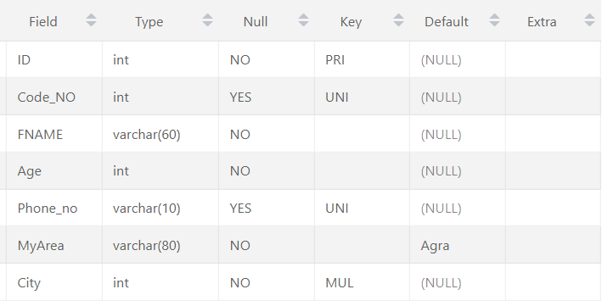

**Practical:-7** Write queries to execute following Aggregate functions Sum, Avg, Count, Minimum and Maximum value of a numeric column of a table using aggregate function.

SELECT *from stu1;

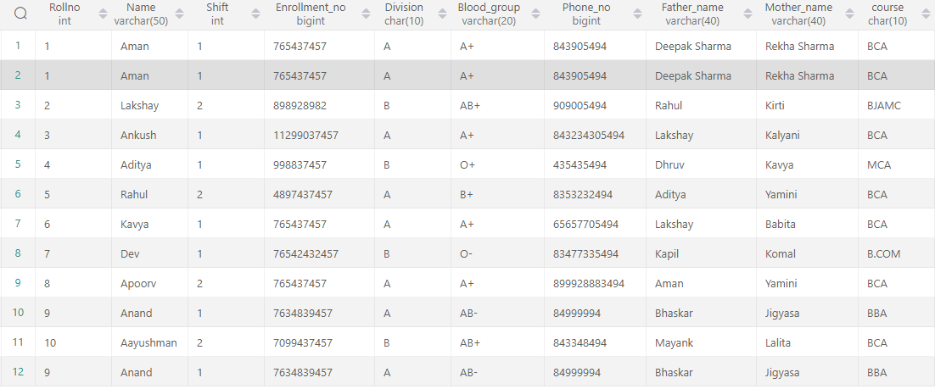

SELECT SUM(shift) As Sum  FROM stu1;

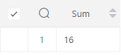

 SELECT AVG(shift) As Average  FROM stu1;

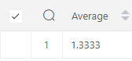

SELECT COUNT(blood_group) FROM stu1;

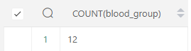

SELECT MAX(shift) As Maximum  FROM stu1;

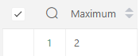

**Practical:-8** Retrieve data from a table using alias names .

SELECT name as Stu_name, division,shift as stu_shift FROM student WHERE Name LIKE 'a%';

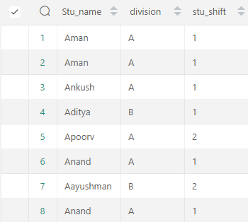

SELECT MIN(shift) As Minimum FROM student;

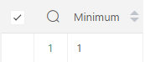

**Practical:- 9** Retrieve data of a table using nested queries.

SELECT * FROM stu1 WHERE division = all (SELECT division FROM stu1 WHERE division = 'a');

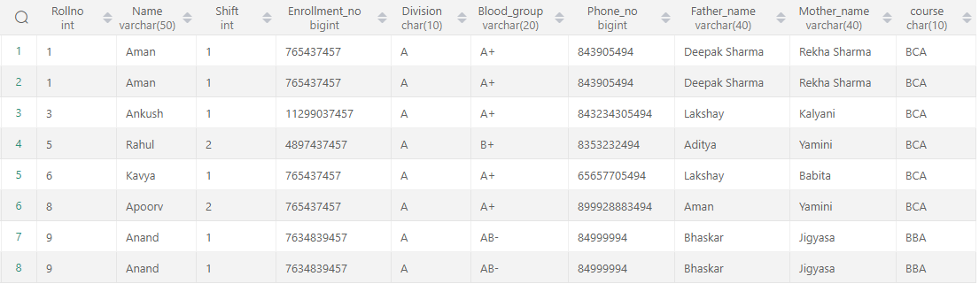

**Question :-10** Retrieve data from more than one table using inner join, left outer, right outer and full outer joins.

1. **Inner join**

select * from semsec inner join class;

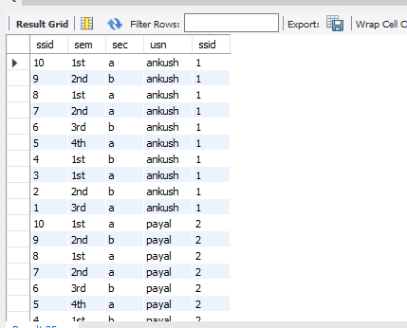

select sec from semsec inner join class;

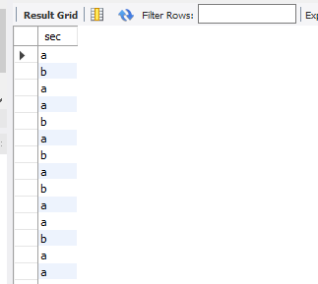

1. **Right outer join**

select * from semsec right join class on semsec.ssid= class.ssid;

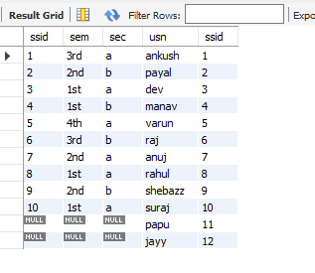

1. **Left outer join.**

select usn,sec from semsec left join class on semsec.ssid= class.ssid;

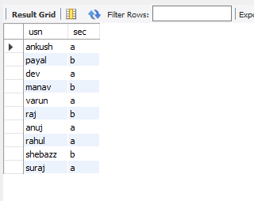

select * from semsec left join class on semsec.ssid= class.ssid;

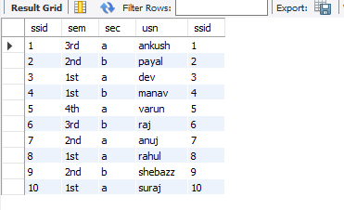.

**Practical:- 11** Create view from one table and more than one table.

CREATE VIEW Stu_info as select Name, Dep_id FROM best ,Program_  WHERE  best.Program = program_.program_id;

SELECT * FROM stu_info;

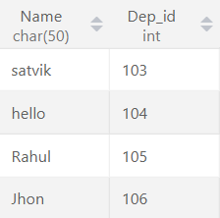

**Practical:- 12** Create index on a column of a table.

create index indexes_A on stu1(rollno, name, blood_group);

show index from stu1;

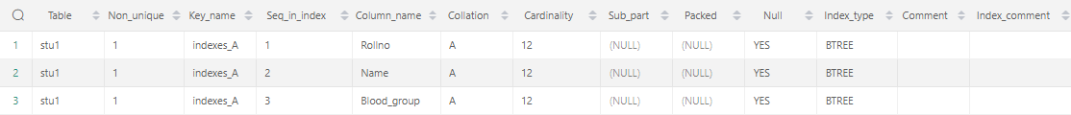

**Practical:- 13** Consider the Insurance company’s Database given below.

The primary keys are underlined and the data typesare specified.

PERSON(driver_id# : string, name : string, address : string)

CAR(regno : string, model : string, year : int)

ACCIDENT(report_number : int, acc_date : date, location : string)

OWNS(driver_id# : string, regno : string)

PARTICIPATED(driver_id# : string, regno : string, report_number : int, damage_amount :number(10,2) )

1. Create the above tables by properly specified the primary key and the foreign key
2. Enter at least five tuples for each relation
3. (A)Demonstrate how you can a. Update the damage amount for the car with a specific regno, the accident with report number 12 to 25000.

(B). Add a new accident to the database.

1. Find the total number of people who owned cars that were involved in accident in2002.
2. Find the number of accident in which cars belonging to a specific models were involved

CREATE DATABASE  Insurance_company;

use Insurance_company;

CREATE TABLE PERSON(driver_id int PRIMARY KEY,Name VARCHAR(50),Address VARCHAR(160));

SELECT * FROM PERSON;

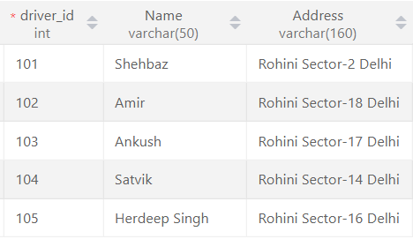

CREATE TABLE CAR(regno VARCHAR(54) PRIMARY KEY, model VARCHAR(99), year int);

SELECT * FROM CAR;

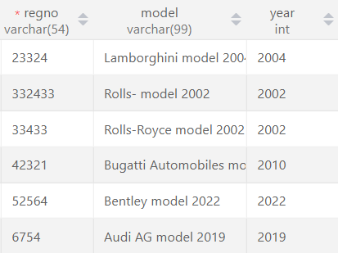

CREATE TABLE ACCIDENT(report_number int PRIMARY KEY, acc_date INT, location VARCHAR(150));

SELECT * FROM accident;

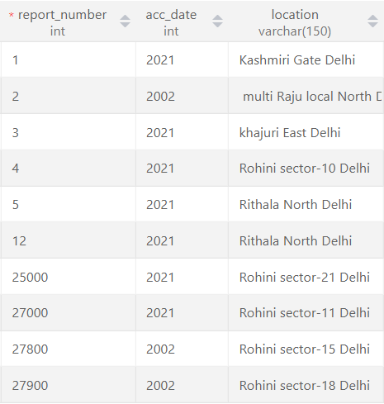

CREATE TABLE OWNS(driver_id INT PRIMARY KEY, regno VARCHAR(54));

SELECT * FROM owns;

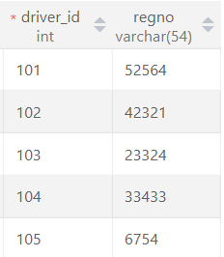

CREATE Table PARTICIPATED(driver_id int UNIQUE KEY , regno VARCHAR(54), report_number int PRIMARY KEY, damage_amount BIGINT );

SELECT * FROM participated;

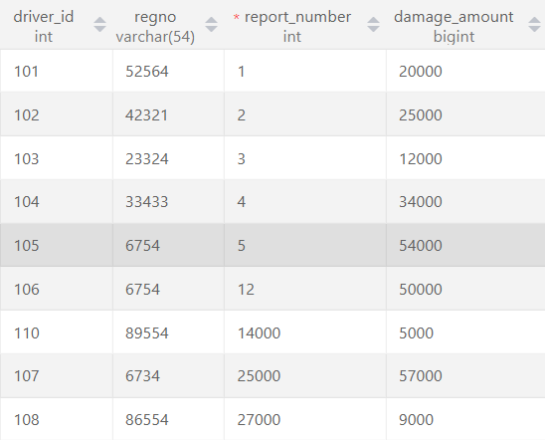

(i) Create the above tables by properly specified the primary key and the foreign key

ALTER TABLE  accident ADD FOREIGN KEY (report_number) REFERENCES participated(report_number);

(ii) (A) Update the damage amount for the car with a specific regno, the

accident with report number 12 to 25000.

UPDATE participated SET damage_amount=damage_amount+1000  WHERE report_number BETWEEN 12 AND 25000 AND regno = 06734;



(ii) (B) Add a new accident to the database.

INSERT INTO accident VALUES(28000,'2021-01-13',"Rohini sector-11 Delhi");

(iii) Find the total number of people who owned cars that were involved in accident in 2002

SELECT COUNT(report_number) FROM accident WHERE acc_date =2002;

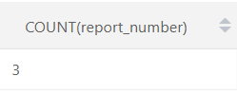

(iv) Find the number of accident in which cars belonging to a specific models were involved

Select count(report_number) as accident_ from ACCIDENT  where  report_number  IN (select report_number from car where model='Rolls-Royce model_ ' OR model="Audi AG model_ ");

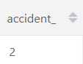

**Practical:-** 14

🡪 Consider the following schema of a library_management system.Write the SQL

🡪 queries for the questions given below;

🡪 Student(Stud_no : integer, Stud_name: string)

🡪 Membership(Mem_no: integer, Stud_no: integer)

🡪 Book_(book_no: integer, book_name:string, author: string)

🡪 lss_rec_(iss_no:integer, iss_date: date, Mem_no: integer, book_no: integer)

🡪 (i) Create the tables with the appropriate integrity constraints

🡪 (ii) Insert around 10 records in each of the tables

🡪 (iii)Display all records for all tables

🡪 (iv)List all the student names with their membership numbers

🡪 (v) List all the issues for the current date with student and Book names

🡪 (vi) List the details of students who borrowed book whose author is Elmarsi & Navathe

🡪 (vii) Give a count of how many books have been bought by each student

🡪 (viii) Give a list of books taken by student with stud_no as 1005

🡪 (ix) Delete the List of books details which are issued as of today

🡪 (x) Create a view which lists out the iss_no, iss _date, stud_name, book name

CREATE DATABASE library_management;

use library_management;

(i) Create the tables with the appropriate integrity constraints

(ii) Insert around 10 records in each of the tables

(iii)Display all records for all tables

CREATE TABLE Student(Stud_no  int PRIMARY KEY, Stud_name VARCHAR(60));

SELECT * FROM student;

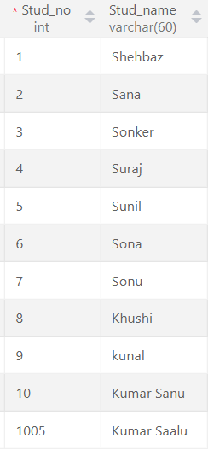

CREATE TABLE Membership(Mem_no int PRIMARY KEY, Stud_no int);

SELECT * FROM membership;

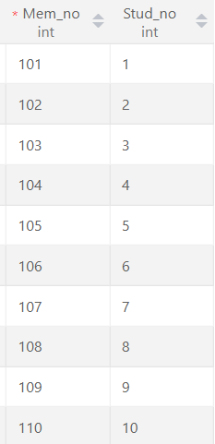

CREATE TABLE Book_(book_no int, book_name VARCHAR(200), author VARCHAR(200));

TRUNCATE TABLE Book_;

SELECT *FROM book_;

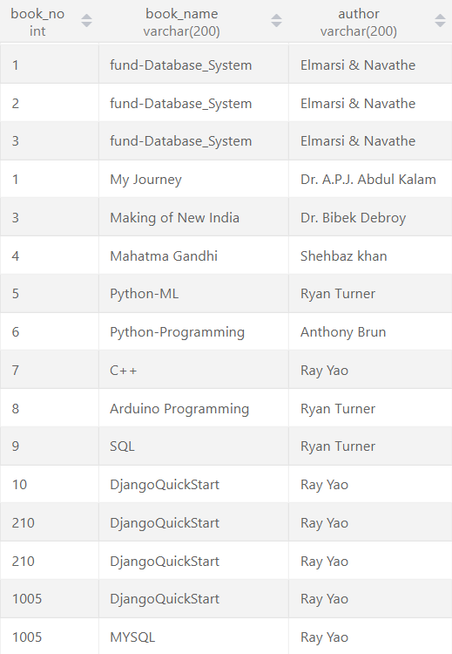

CREATE TABLE lss_rec(iss_no_ int PRIMARY KEY, iss_date date, Mem_no int, book_no int);

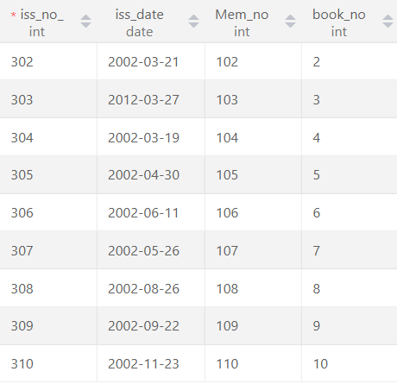

(iv)List all the student names with their membership numbers

SELECT Mem_no,Stud_name FROM membership JOIN student WHERE membership.Stud_no =student.Stud_no;

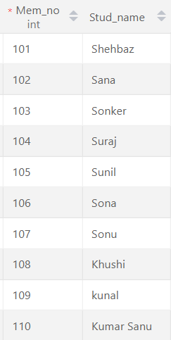

(v) List all the issues for the current date with student and Book names

select Stud_name, book_name from student, book_, lss_rec ,membership where iss_date= '2002-03-19' AND student.Stud_no= membership.Stud_no AND  lss_rec.Mem_no= membership.Mem_no AND lss_rec.book_no= book_.book_no;

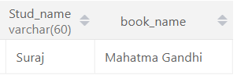

(vi)List the details of students who borrowed book whose author is Elmarsi & Navathe

Select *from student where Stud_no IN(select book_no from book_ where author = 'Elmarsi & Navathe');

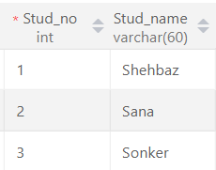

(vii) Give a count of how many books have been bought by each student

select count(book_no) from lss_rec;

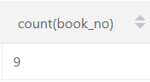

(viii) Give a list of books taken by student with stud_no as 1005

select book_name from book_ where book_no=(select book_no from lss_rec where Mem_no=(select Mem_no from membership where Stud_no= 1005));

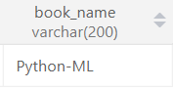

(ix) Delete the List of books details which are issued as of today

DELETE FROM book_ WHERE book_no = (SELECT book_no FROM lss_rec WHERE iss_date= '2012-03-27' );

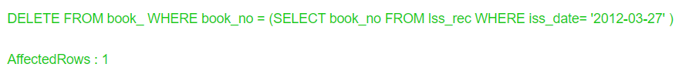

(x) Create a view which lists out the iss_no, iss _date, stud_name, book name

create view info1 as select iss_no_, iss_date, Stud_name, book_name from lss_rec, student, book_ , membership where lss_rec.Mem_no=membership.Mem_no AND student.Stud_no=membership.Stud_no AND book_.book_no=lss_rec.book_no;

select *from info1;

